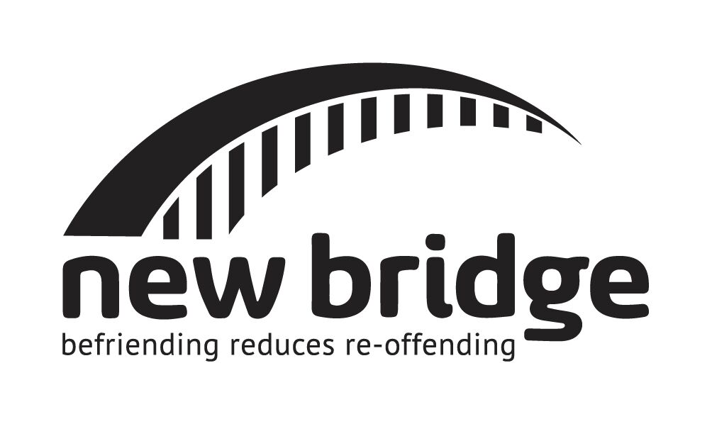
  Volunteer Application Form
Please complete all sections of this form, providing as much detail as possible. The information you provide will be used to determine your suitability to become a volunteer and will be treated in the strictest of confidence.
E-mail completed application form to: volunteering@newbridgefoundation.org.uk

Personal Details
Title |  | First Name(s) |  |  |  |  |  |  |  |  | Surname
Address
Including Postcode

D.O.B. |  |  |  | / |  |  | / |  |  | Mobile No.
Daytime Tel. |  |  |  |  |  |  |  |  |  | Evening Tel.
Email Address

Employment & Education
Employment Status  Please circle as appropriate | Employed / Unemployed / Retired / Student / Carer / Other
Description of current Employment or Studies
Languages spoken other than English

How did you hear about New Bridge?
Word of mouth
Twitter
LinkedIn
Facebook
Google search
My university (please specify which university): ________________________
Other (please specify):________________________

Why are you applying to New Bridge?

Why are you applying to New Bridge? What do you hope to get out of the experience?

Why do you think you will make a good volunteer? How do you think you are well-suited to supporting someone in prison?

Rehabilitation of Offenders Act (1974)
New Bridge is committed to the fair treatment of staff volunteers and prisoners. We recognise the contribution that all people can make to the organisation and welcome applications from a wide range of candidates including those with criminal records. We understand that potential volunteers who have criminal records may be reluctant to apply for voluntary work where this would involve the disclosure of their record. We appreciate that people are often ashamed and embarrassed about their cautions and convictions and/or they fear they will not be treated fairly because of them. We ask that volunteers have two years clear of any supervision or detention.

We will need to know about ALL criminal convictions (served, pending, spent and unspent) and cautions you may have received. Please rest assured that we will handle the information you provide us in confidence. Failure to disclose any relevant information could result in the termination of your volunteering with us. If you require any further information about your rights in relation to Disclosure applications, and our responsibilities to you, please see the Disclosure and Barring Service’s website: www.homeoffice.gov.uk/agencies-public-bodies/dbs

Do you have any criminal convictions, cautions or pending court cases?

No:
Yes:

Details of all convictions and/or cautions:
[Alternatively, should you wish to provide details of convictions and cautions under separate cover, please send to New Bridge Volunteer Director and tick the box to indicate you have done so.]

References
Please provide the names and contact details of two referees (not close family members or partners please) who can comment on your suitability, skills and abilities for this role and who have known you longer than two years. One of your referees should be someone who has known you in a professional capacity and could be your current or most recent employer. If you are unable to provide these please contact us to discuss further.
Referee 1
Name |  | Relationship to You
Email
Address
Including Postcode

Referee 2
Name |  | Relationship to You
Email
Address
Including Postcode

Declaration - Please read carefully
- I declare that, to the best of my knowledge, the information I have provided in this Application Form is true and accurate. The information requested in this application will be used only for the purpose of determining my suitability as a New Bridge Volunteer and I understand that if it subsequently discovered that any statement I have provided is false or misleading; my voluntary position may be terminated without notice.

- New Bridge employs a continuous Volunteer selection process and I understand that my application may be discontinued at any stage during this process should I be deemed unsuitable for this role. I am aware that I will only become an accredited New Bridge Volunteer and be able to commence befriending/mentoring a prisoner following successful completion of the following:
1) Application Form
2) Interview
3) Two satisfactory references
4) Attendance at training session

- I understand that I am required to disclose ALL criminal convictions, cautions or pending court cases

Signature:____________________________________________ Date:__________________________

Volunteer Monitoring Form
New Bridge has an Equal Opportunities Policy to ensure that all applicants are treated fairly and are selected solely on their suitability for the post irrespective of race, gender, disability, sexuality, age, ethnicity, nationality, religion, language, political opinion or affiliation, gender reassignment, marital status, family connections, caring responsibilities or unrelated criminal conviction. All stages of the recruitment process are monitored to check that unfair discrimination is not taking place.

Please complete the following by ticking the relevant boxes.

- Ethnic Origin:

Self-classified (please specify)

Prefer not to specify

- Gender:

Self-classified (please specify)

Prefer not to specify

- Preferred pronouns

Self-classified (please specify)

Prefer not to specify

- I have a disability I would like New Bridge to know about, e.g., mobility difficulties, epilepsy,
diabetes, sensory impairment, depression, etc:

Yes |  |  | No

If yes, please provide details:

- I have special requirements you will need to take into account in interview:

Yes |  |  | No

If yes, please provide details and how we may assist:

